The Agresti-Coull C.I. Procedure
for A Biniomial Proportion

As it happens, the standard interval 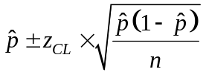has pretty poor, erratic behavior. This has recently lead statisticians into a vigorous pursuit of better methods. While there is no one definition of “better”, one important criterion is attained coverage rates: how does it compare to the chosen (also called “nominal”) rate”?

The standard method exhibits actual coverage rate that vary wildly, depending on the true underlying proportion p. The following figure illustrates actual coverage rates for four C.I. methods for n = 50, chosen confidence level of 95%, and a range of underlying proportions p. Notice that the standard interval, is often unfortunately under-covering. The Agresti-Coull interval, on the other hand, is usually closer to nominal (95%). Most statisticians would prefer to be conservative (i.e. have the method cover more than you declare), in which case the A-C method is clearly superior to the standard method.

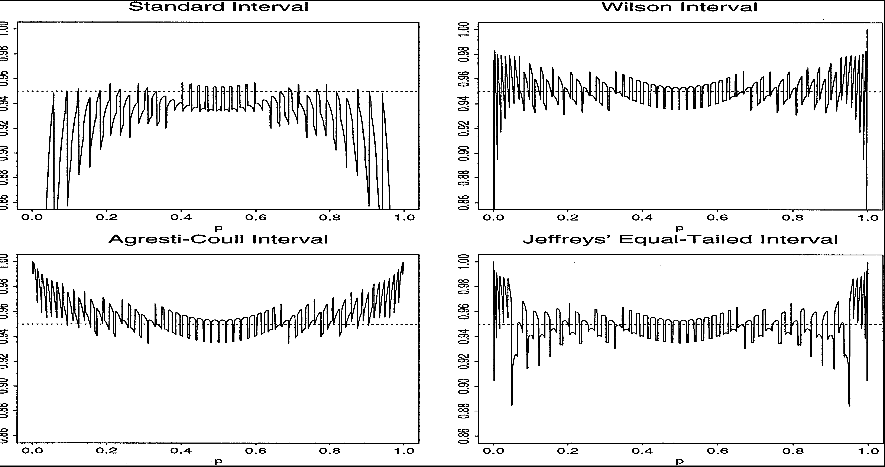
Figure 5 from Brown et al, 2001. It shows (from a detailed simulation study) the attained coverage rates of putative 95% intervals, given a true underlying proportion p between 0 and 1. Here, n = 50.

Another way it performs (counter-intuititively) badly is that improvement in coverage doesn’t come (guaranteed at least) as sample size increases.The following figure illustrates

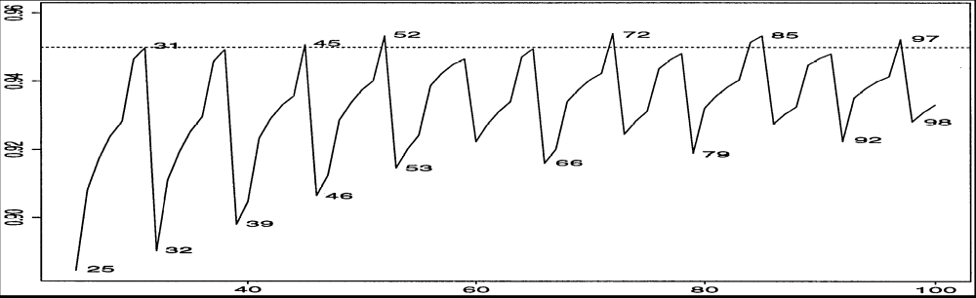
Figure 1 from Brown et al, 2001. It illustrates coverage rates of nominal 95% intervals for the standard method when p = 0.2, for n from 25 to 100. There are some “unlucky” sample sizes that can not be explained away, except in a general hand-wavy way.

The Agresti-Coull method (which I’ll explain in detail soon) behaves surprisingly well compared to the standard method, even for small sample sizes, as the next figure shows.

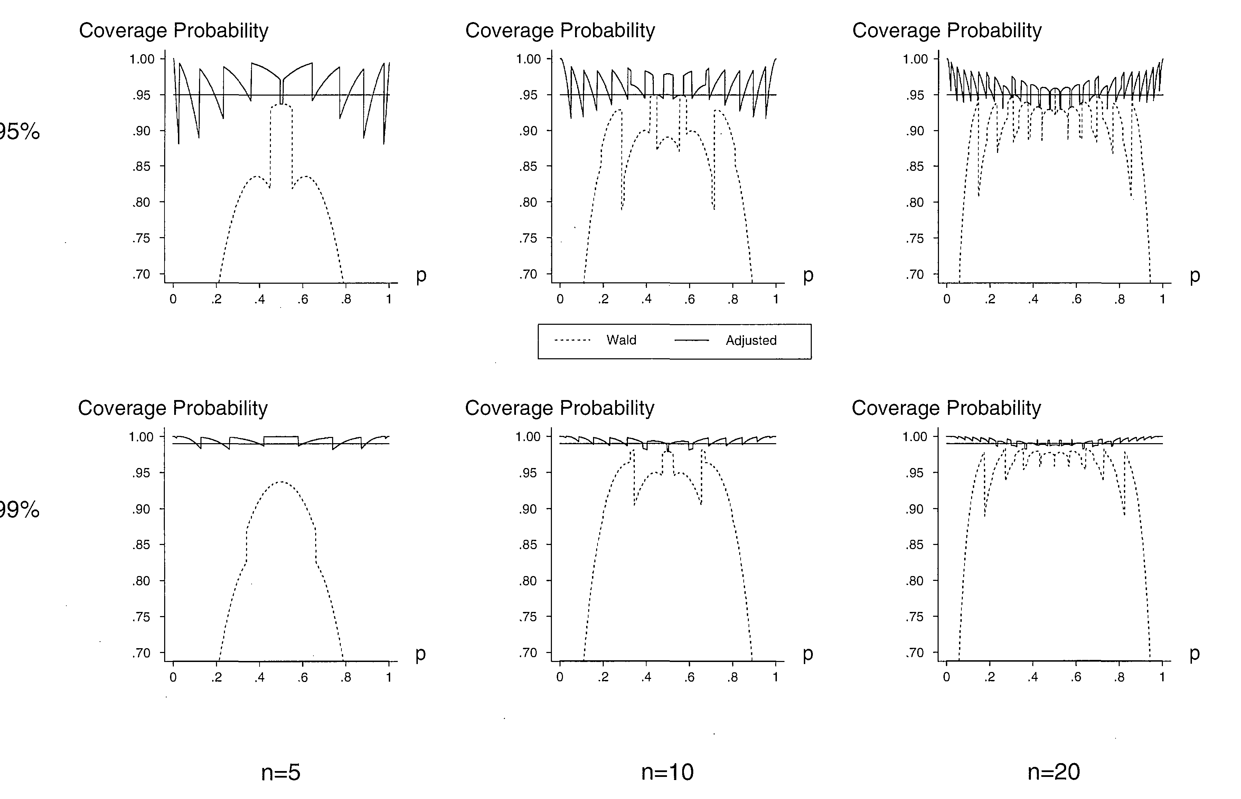
This figure is from Agresti and Caffo, 2000.

Point taken: the A-C method works better. Now, then, what is it? Let 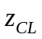be the value from the standard Normal distribution such that CL% of the distribution lies between 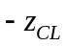 and . Let Y symbolize the number of “successes” in a sample of n so that 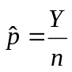 is the usual estimator for p. Define 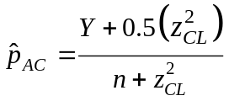, and create a “standard-type” interval from this adjusted estimate: 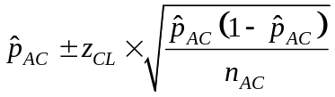, where 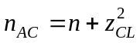 (I bothered to create the notation 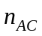 only so you could see that the A&C interval construction exactly parallels the standard one. Now, in general, you can’t do this with statistics packages. You can do it by hand (or with a Stats Alive Excel tool ☺), with one exception. If you choose the 95% confidence level, 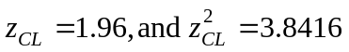, which can tolerably be approximated by 2 and 4, respectively. Hence the (quickly becoming famous) “+4” C.I. method is simply (for 95% C.I. ONLY): 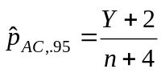

References

Agresti, A. and Coull, B.A. (1998). “Approximate is better than Exact for Interval Estimation of Binomial Proportions,” The American Statistician, 52, 119-126.
Agresti, A., and Caffo, B. (2000), “Simple and Effective Confidence Intervals for Proportions and Differences of Proportions Result from Adding Two Successes and Two Failures,”, The American Statistician, 54, 280-288.
Brown, L. D., Cai, T., and DasGupta, A. (2001), “Interval Estimation for a Binomial Proportion (with discussion),” Statistical Science, 16, 101-133.

Better meaning better performance. In some cases it comes at a computational price.
If you want to learn about the other methods, go read the two references. For statisticians, they are both reasonably non-technical; non-statisticians might not agree with that characterization.
We know the standard method does not work well for small sample sizes (recall the (variously stated) admonition to have at least 10 successes and 10 failures)?
i.e. it is the value you would use to create the margin of error for a standard interval.

